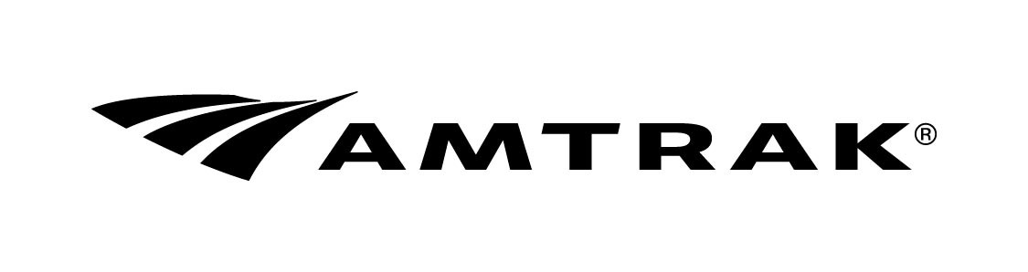
Private Car Movement Request

Date  / / | Name of Private Car Owner or Designee |  |  | Telephone Number  - - |  | Cell Phone Number  - -
Street Address |  |  | Car Cell Phone Number  - - |  | Person in Charge Cell Phone Number  - -
City |  | State | Zip Code | E-Mail

 | Amtrak  Car No. | Car Name | Person in Charge of Car | UMLER No. | Brake System
Car A
Car B
Car C
Car D

Itinerary
Car(s)  Position | Train | Date | Origin  Code | Dest.  Code | Location  Board/Detrain | Parking/Layover
 |  |  |  |  |  | Dead | Pwr | Occ | Other Services
 |  | / /
 |  | / /
 |  | / /
 |  | / /
 |  | / /
 |  | / /
 |  | / /
 |  | / /
 |  | / /
 |  | / /

Indicate whether any passengers on this private car move have paid for this travel. | Yes | No

Other Information

Car(s) Current Location/Final Disposition
My signature below indicates that I wish to move my privately owned railcar on the Amtrak train(s) shown above. I understand that this movement request, if accepted, will be governed by the applicable provisions of the “Conditions for Movement of Privately-Owned Railroad Cars on Amtrak” effective October 1, 2023, including all amendments.
Printed Name | Signature | Date: / /
Submit Completed Form to: Amtrak Special Movements FAX: 302-683-2121
CNOC TEL: 302-683-2443
15 South Poplar Street E-Mail: SpecialMoves@amtrak.com
Wilmington, DE 19801

NRPC 2208 (REV. 08/2023) Amtrak is a registered service mark of the National Railroad Passenger Corporation.

